# Model

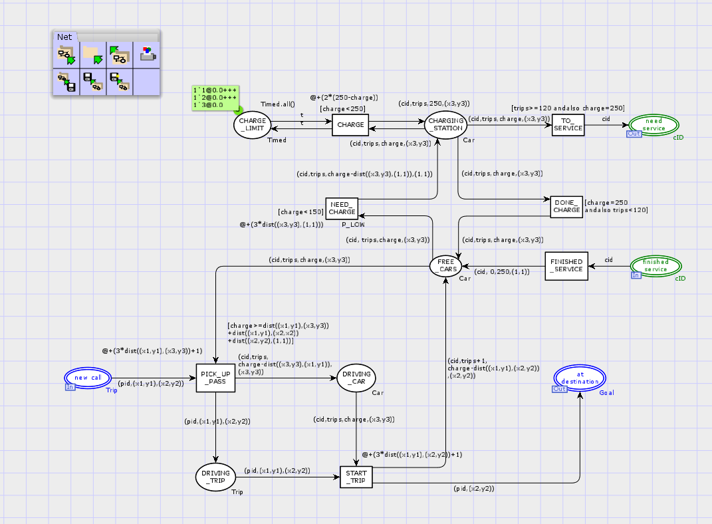

# Model Description

* After a car completed service in the garage, its car id is available in place (finished service). From there it takes transition FINISHED_SERVICE to place FREE_CARS. FINISHED_SERVICE adds the cid to its corresponding car with full charge and 0 trips and position (1,1).
* From FREE_CARS the car can either go to the charging station and recharge or it can be used to pick up a new TRIP.
* If the Car has less than 150 charge it can go to the CHARGING_STATION. If it does, its’ charge is updated properly. The charging station can charge up to 3 Cars at once. Once a Car has been fully charged, the Car can go back to the FREE_CARS place, or, if it has taken more than 120 trips since the last service, it will go to the need service place.
* When a Trip is to be picked up by a Car, their corresponding times are updated and the Cars charge is decreased appropriately. The Trip then goes to the DRIVING_TRIP place and the Car goes to the DRIVING_CAR place.
* Once the Car has picked up the Trip, the Car drops off the Trip at the destination. In this step the time and variables of both are updated respectively.

# Declarations, Guards, Arc Inscriptions, Functions

## Declarations

|  |  |
| --- | --- |
| t | A variable of type Timed |
| X3,y3 | Variables of type INT |
| Timed | A timed integer used to limit charging to 3 cars at a time |
| Car | a collection of information representing a car. A Car contains a cid, an integer representing the amount of trips since the last service, an integer representing the remaining charge, and a location representing the cars current location |

## Guards and Arc Inscriptions

|  |  |  |
| --- | --- | --- |
| Guard/Arc Inscription | Where is it in the model? | Explanation |
| [charge>=dist((x1,y1),(x3,y3))  +dist((x1,y1),(x2,x2))  +dist((x2,y2),(1,1))] | This is the guard of PICK_UP_PASS | This limits cars that can pick up Trips to cars that can complete the trip without running out of charge |
| (cid,trips+1,  charge-dist((x1,y1),(x2,y2))  ,(x2,y2)) | This is the Arc inscription from START_TRIP to FREE_CARS | This updates the cars variables. Charge if decreased by the amount it used to drive from where the Trip was picked up to where it was dropped off. Trips is increased by one. The position of the car is updated to where it dropped of the Trip |
| @+(2*(250-charge)) | This is attached to the CHARGE transition | This updates the car and Timed with the amount of time they used to charge a car. |

# Simulation Results

## Summary of Simulation Results

From the simulation report it can be seen that my model always completes 1000 trips successfully with on average only 238 trips taking too long.

## Raw Simulation Reports

